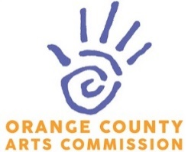
July 2025 Agenda
Monday, July 14| 6:30pm
Music Maker Foundation, Hillsborough

Agenda
- Call to Order Crystal Wu
- Approval of May Board Minutes Crystal Wu
- Board updates
  - Alex Gast - appointed
  - Jonathan Hamiel – waiting to meet
  - Ashley Nissler – vote needed
- Director’s Report Katie Murray
  - Mill
  - Cloth Mill space
  - Uproar update
  - August: “Common Good” Benefit Auction
  - Paint it Orange
- Grants Katie Murray
  - Schedule of panels
  - Applicant overview
- Liaison Reports
  - UNC Student Liaison Update
  - Chapel Hill Arts Commission
  - UNC Crystal Wu
  - Hillsborough Arts Council John Bemis
  - The ArtsCenter Wendy Smith
  - Carrboro Arts
  - Visitor's Bureau Wendy Smith
  - Orange County Artists Guild Heather Washburn
  - Carolina African American Writers’ Collective/Carrboro Poets Council Gideon Young
- Board member updates All

IMPORTANT DATES (bold = volunteers needed) – sign up here
Wed June 11 7-9pm Daniel Wallace Reading & Signing (Vteers – Gail and Doris)
Fri June 13 6-9pm Juneteenth Celebration (need bartenders)
Wed June 18 7-9pm Weave & Spin (Vteer – Wendy)
Fri June 27 6-9pm Last Fridays – tabling for Uproar and Camps (Vteer – Francesa)
Fri July 4 7-9pm First Fridays feat. Focal Point: Orange and Al Strong

