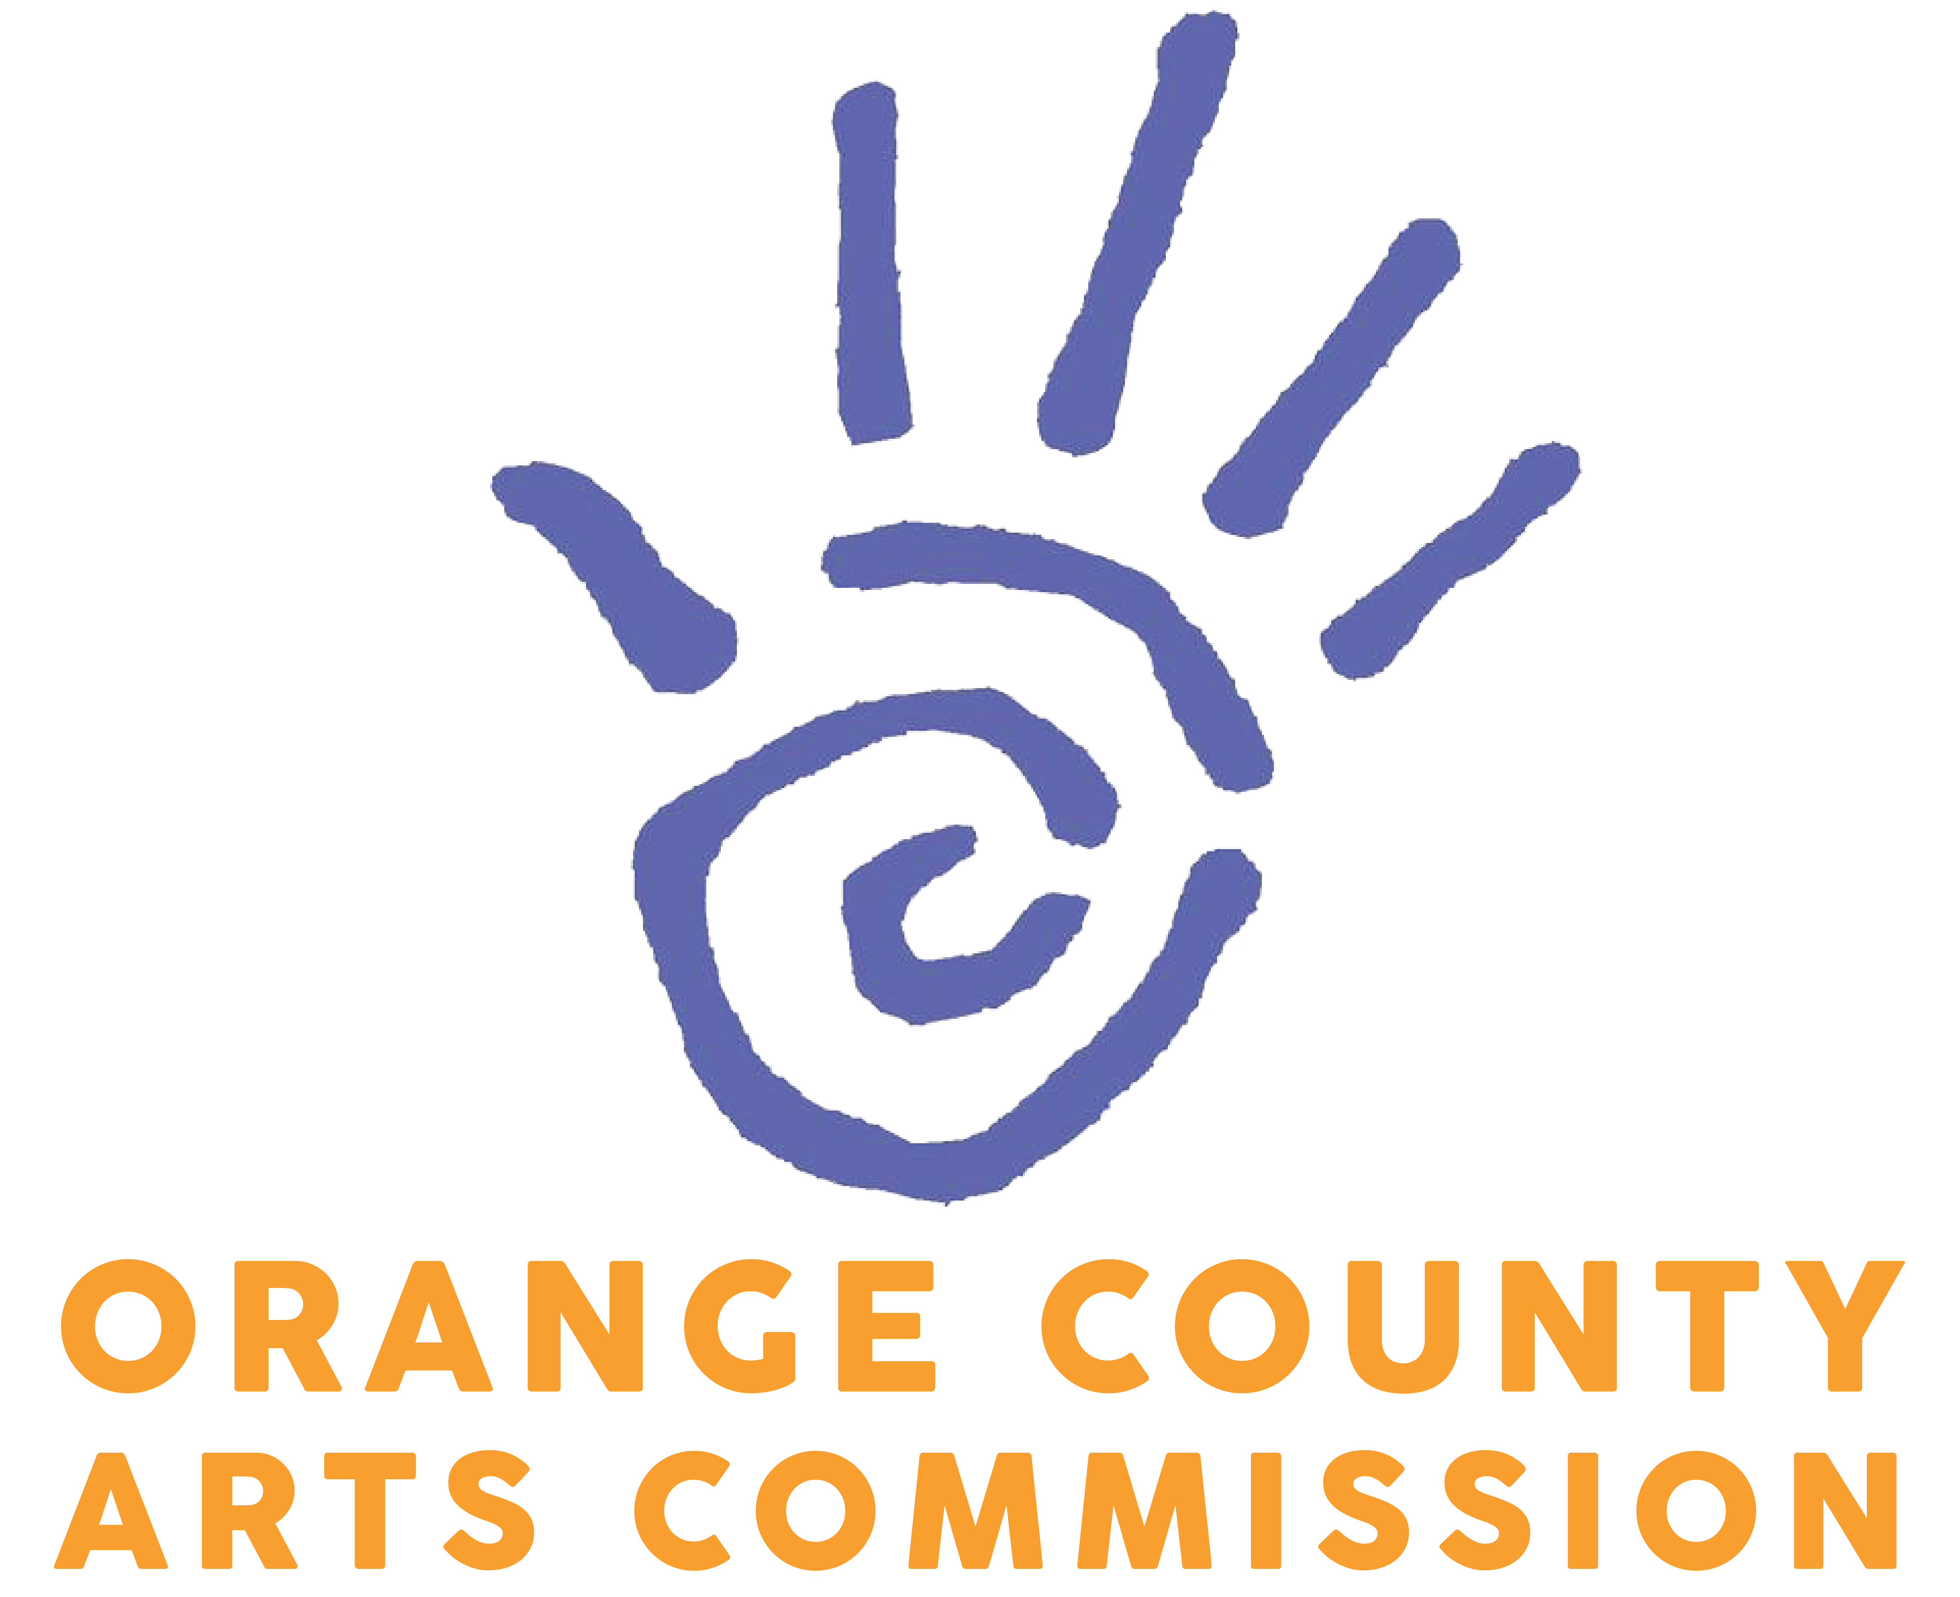

March 21, 2017

Dear Potential Grassroots Grant Applicants:

In order to better serve the arts community, the Orange County Arts Commission (OCAC) has made significant changes to our grants process that we want you to be aware of. The purpose of these changes is to make our grants application process easier more efficient, encouraging a broad and diverse pool of applicants. The changes taking effect with the upcoming grant cycle include the following:

- The OCAC will host one annual grant cycle in the spring, instead of two cycles in the spring and fall cycle. The 2017 Grassroots Grant cycle will open April 3 and close June 2. Awardees will be notified by August 1. Projects must take place during the 2017-18 fiscal year (July 1, 2017 through June 30, 2018). This will be the only opportunity to apply for Grassroots Grants until spring of 2018.
- We are transitioning from five to two grant categories:
  - Grassroots Arts Program Grants: Funded by the NC Arts Council (NCAC) and Orange County, these grants fund arts programs, projects, and services through area nonprofits, schools, and municipal organizations.
  - Artist Project Grant Applications: Funded by Orange County, these grants fund individual artist projects that positively benefit the greater community.
- We will remove the current grant request limits and offer a suggested range of $500-$3,000 per application.
- We will continue to help you submit a competitive application, as long as you submit your grant early enough for it to be reviewed. Incomplete applications will not be accepted and will be removed from the applicant pool.
- The OCAC will closely follow the NCAC Priorities of Funding guidelines in selecting funded applications (these funding priorities are explained in the application packet).
To further explain these changes, as well as provide tips regarding the application process, the OCAC will host two grant training sessions to assist you:
- Chapel Hill Training Session: Tuesday, April 18 at 6pm at Chapel Hill Public Library, Meeting Room C. (100 Library Drive, Chapel Hill, NC 27514)
- Hillsborough Training Session: Thursday, April 6 at 6pm at Link Government Services Building Conference Room (200 S. Cameron Street, Hillsborough, NC 27278)
The OCAC looks forward to helping you develop programs, projects or services to promote the cultural arts in Orange County. Please see the enclosed application form and F.A.Q.’s to help you with this process. Please feel free to contact me at kmurray@orangecountync.gov or at 919-245-2335 if you have any questions.

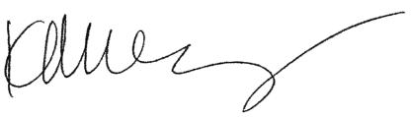
Sincerely,

Katie Murray
Director, Orange County Arts Commission

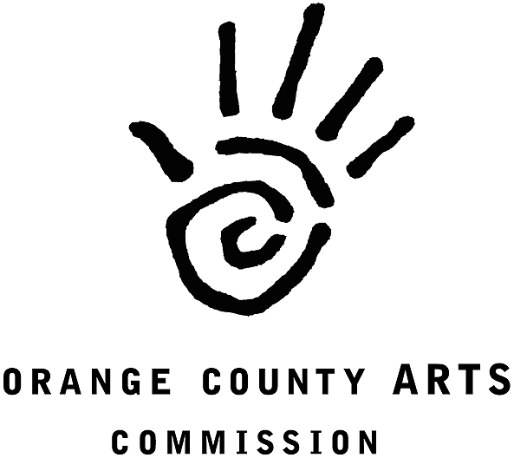
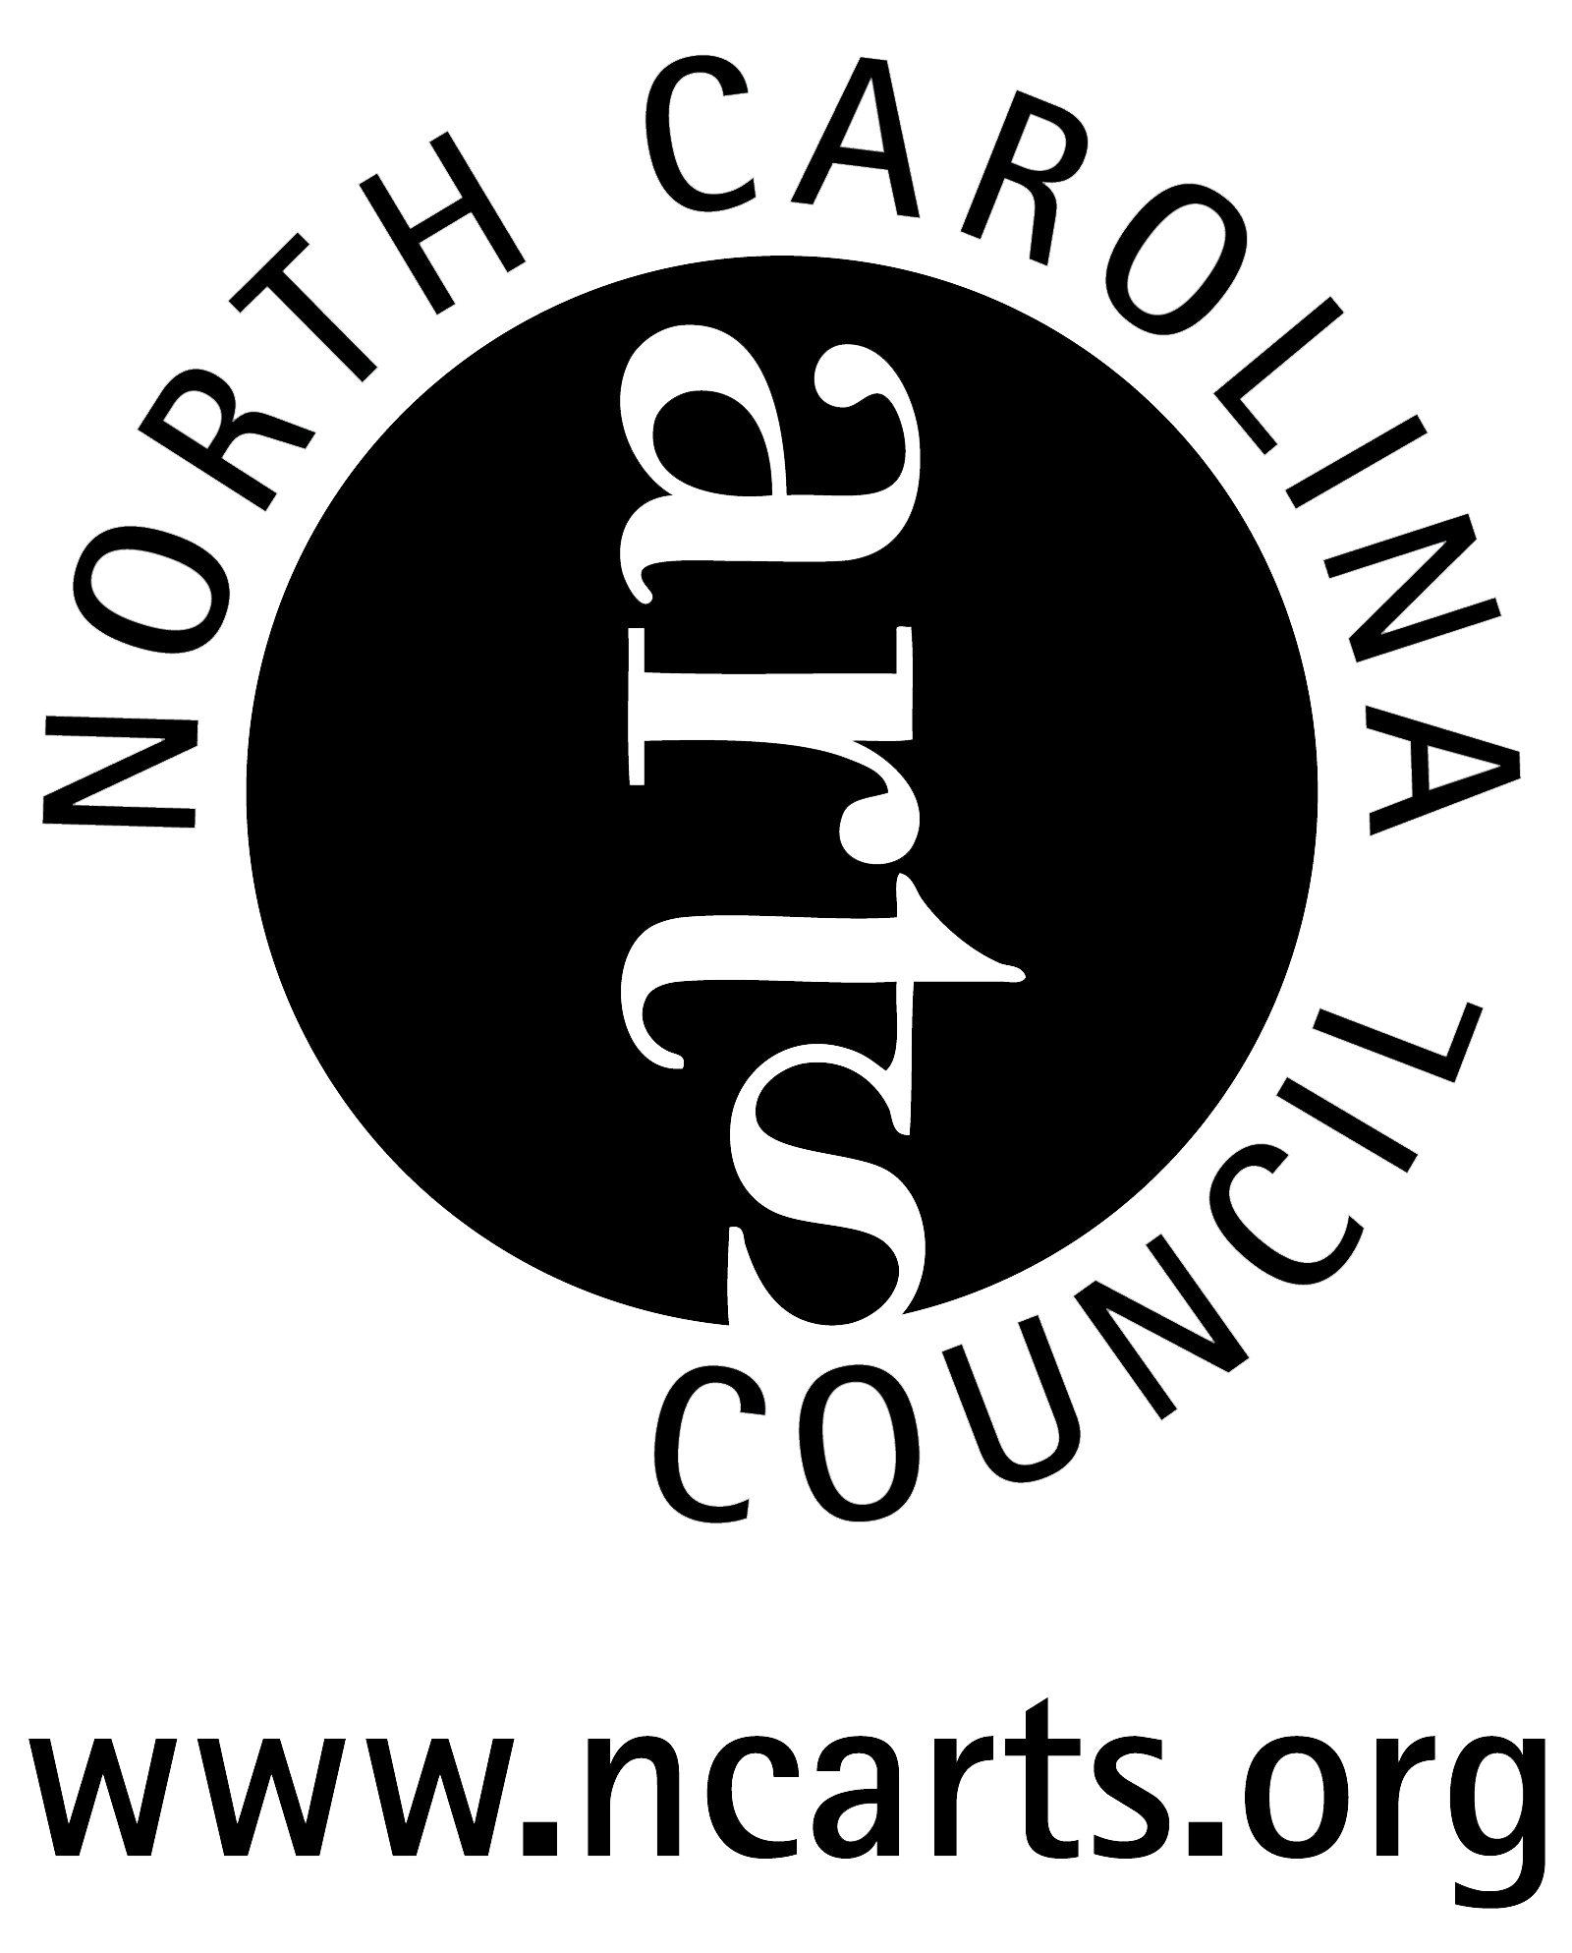
2017-18
GRASSROOTS ARTS PROGRAM
GRANT APPLICATION GUIDE

GUIDELINES FOR GRASSROOTS ARTS PROGRAM APPLICANTS

Since 1977, the N. C. Arts Council’s Grassroots Arts Program has provided North Carolina citizens access to quality arts experiences. The program distributes funds for the arts in all 100 counties of the state primarily through partnerships with local arts councils. The Orange County Arts Commission (OCAC) serves as the N. C. Arts Council’s partner in awarding subgrants to local organizations for arts programs in Orange County, as well as additional grant funds approved by the Orange County Board of County Commissioners.

ELIGIBILITY FOR APPLICATION
- All organizations must have been in operation for at least one year, and must be either a nonprofit organization or have a nonprofit sponsor to receive funds on their behalf.
- All organizations must reside or carry out projects within Orange County.
- Organizations that receive general support funds through the N.C. Arts Council are not eligible for Grassroots funds.
- Individuals are not eligible to apply for Grassroots Arts funds.
- Applications and support materials must be complete and received (not postmarked) by the due date.

APPLICATION SUBMISSION & TIMELINE
- Application forms may be downloaded from the OCAC site at http://www.artsorange.org/grants
- 2017 Timeline:
  - Monday April 3: Application Period opens
  - Thursday, April 6: Hillsborough Training Session- 6pm at Link Government Services Building Conference Room (200 S. Cameron Street, Hillsborough, NC 27278)
  - Tuesday, April 18: Chapel Hill Training Session - 6pm at Chapel Hill Public Library, Meeting Room C. (100 Library Drive, Chapel Hill, NC 27514)
  - Friday, June 2: Applications are due to the OCAC office by 5pm
    - Drop off in person at Orange County Arts Commission office. Please note our new location in the Link Government Services Building: 200 S. Cameron St., Hillsborough.
    - By mail: Orange County Arts Commission-P.O. Box 8181, Hillsborough, NC, 27278
  - No later than Tuesday, August 1: Applicants will be notified in writing
- All projects must take place between July 1, 2017 and June 30, 2018 (this means you can apply for a project that may have already happened before you are notified).
- The suggested grant request amount is $500 - $3,000. (Recommended, but not required.)

FUNDING GUIDELINES
Grassroots Arts Program funds may be used for expenditures to conduct quality arts programs, or operate an arts organization. Typical uses of Grassroots money include:
- Program expenses such as professional artists’ fees and travel, space rental, advertising, marketing and publicity, website and electronic media, scripts, costumes, sets, props, music and theater equipment rental.
- Operating expenses for qualified arts organizations not already receiving operating support from the N.C. Arts Council. These can include salaries, telephone, office supplies, printing, postage, rent, utilities, insurance and equipment rental.

Funding Policies
- Tribal organizations that receive grassroots funds must represent state or federally recognized tribes.
- Colleges, universities and libraries may receive grants for arts programs that are community based or generate regional arts involvement. Grants may not support their internal programs, administration or operation expenses (library books, band boosters, equipment purchases).
- Grassroots funds may not be awarded to individuals.
- Grassroots funds may not be used for art supplies or equipment purchase.
- Grassroots funds may be used for student transportation to regional arts exhibits and programs on a limited basis.
- Grants may not be awarded for prizes, competitions, scholarships, tuition or financial awards.
- Religious organizations or churches may not receive Grassroots funds unless the programs are presented outside regular church services, engage the larger community and do not contain religious content.
- Grassroots funds may not be used for activities associated with a school’s internal arts programs, such as in-school student performances, the purchase of art supplies, or student arts competitions and publications.
- Municipalities (city/county government) and community organizations may receive grants for arts programs that use qualified artists to conduct programs that involve the greater community. Grants may not support internal programs, administration or operating expenses.
- Grassroots Arts Program money may not be used for the following kinds of expenditures:
- Art, music, and dance therapists
- Artifacts
- Purchase artwork
- Capital expenditures
- Contingency funds
- Deficit reduction
- Fundraising events
- Food or beverages for hospitality or entertainment functions
- School band activities or equipment
- School choral activities
- Lobbying expenses
- Oral history and history projects
- Tuition for academic study
- Interest on loans, fines or litigation costs

Matching Requirement
All grantees are encouraged to match their grant amounts dollar for dollar. The funds must come from other public or private sources. Other N.C. Arts Council funds or state funds (i.e. public university dollars) cannot be used as a match.

Racial and Cultural Diversity Requirement
The NCAC works to provide a representative portion of grant funds for arts programming that reflects the racial and cultural diversity of the state. The OCAC is required to spend 23% of its annual county allotment for programming that reflects African American, Asian American, Latino, and Native American cultures, based on the percentage of each population in Orange County.

APPLICANT EVALUATION
Applications are reviewed by the OCAC Advisory Board. The panel evaluates applications based on the NCAC Priorities for Funding (below) and the following criteria:
- Artistic quality of proposed project or programs
- Community impact of project or programs
- Multicultural aspect of the program
- Educational impact of the project
- Ability to plan and implement project
- Stability and fiscal responsibility of the organization

Panelists discuss and score the grant using an established rating system. The highest scoring applications are funded and the dollar amount granted to each applicant is determined.

North Carolina Arts Council Priorities for Funding
The first priority of the Grassroots Arts subgrant program is to provide operating or program support to qualified arts organizations including theaters, symphonies, galleries, art guilds, choral societies, dance companies, folk arts societies, writers groups and arts festivals, among others. Grassroots funds are not generally awarded to arts organizations that receive funding through the N.C. Arts Council’s General Support Program.

The second priority of the Grassroots Arts subgrant program is to support arts learning and arts in education programs conducted by qualified artists. These can be artist residencies in schools, after school summer camps or adult arts learning classes.

The third priority of Grassroots Arts subgrants is to support community organizations that provide quality art experiences for the greater community. These programs must be conducted by qualified artists.

GRANTEE REQUIREMENTS
NCAC/OCAC Recognition
Grantees must acknowledge the N. C. Arts Council and Orange County Arts Commission’s support of their event or projects by including their logos and funding credit lines in all print and promotional materials related to the grant. The OCAC’s website offers information and downloadable logos at www.artsorange.org.

Reporting Requirements
Each grantee is required to submit a final report providing a detailed description of the funded project, participation statistics and demographics, sample marketing and program materials using the N. C. Arts Council credit line and logo, and copies of their legislative letters. The Report Forms will be sent to you by OCAC director Katie Murray and will be due by Wednesday, August 1, 2018. Organizations who have not submitted reports for prior grants are not eligible to apply.

Legislative Letters
Grantees may be required to write their state representatives to thank them for appropriating Grassroots funds. If required, the letter should provide information about how Grassroots funds were used to support your program or project, and the community impact of the event. A copy of all letters to legislators must be included in the subgrantee’s final report.

QUESTIONS & ASSISTANCE
If applicants have questions or need assistance, please contact Katie Murray at 919-245-2335 or kmurray@orangecountync.gov.

2017-18
GRASSROOTS ARTS PROGRAM
APPLICATION FORM

PART 1: APPLICATION ORGANIZATION INFORMATION

Organization Name:
Street Address:
City: | State: |  | Zip:
Phone: |  | Website:
Authorizing Official Name:
Authorizing Official Title:
Authorizing Official Phone: |  | Authorizing Official Email:
Applicant Race: |  | Organization EIN:

ORGANIZATIONAL FINANCES
Please attach a complete income and expense statement (an audit may be substituted) for your last fiscal year and complete operating budgets for the current fiscal year and next fiscal year. Public schools and other large governmental or community agencies should attach arts program financial information only. Please copy the totals from these attachments in the spaces below:

Last Year Actual: FY15-16 | Current Year: FY16-17 | Next Year: FY17-18
Actual Income: $ | Projected Income: $ | Projected Income: $
Actual Expenses: $ | Projected Expense: $ | Projected Expense: $

PART 2: PROJECT INFORMATION

PROJECT DIRECTOR INFORMATION (if different from Authorizing Official)
Project Director Name:
Project Director Title:
Street Address:
City: | State: |  | Zip:
Phone: |  | Email:

PROJECT SUMMARY
Title of Grant Program or Project:
Grant Amount Requested:
Project Start Date (No earlier than July 1, 2017):
Project End Date (No later than June 30, 2018):

SCHOOLS ONLY:
Are you booking your artists through The ArtsCenter’s Arts in Schools Program? □ YES □ NO

PROJECT NARRATIVE
Please attach a narrative providing the information requested below for the project you propose. Please be as concise and specific as possible:
- Please give a brief description of your organization, including mission, board and staff composition, current arts programs and services and number and kinds of people served. Public schools and other large governmental or community agencies should provide a description of their arts program only rather than the entire organization. (250 words or less)
- Offer a brief summary of the proposed project.
- State your project’s goals.
- Offer a description of intended participants/audience, including estimated numbers and racial and cultural composition. For school applications please include the demographic breakdown of the student body, as well as the percentage of students on the Free and Reduced Lunch Program.
- Describe the location where project will take place.
- Explain all project activities.
- Describe all artists to be involved in the project, how and why they were chosen, and the rate of payment for their services. If you have not yet selected the artists, describe the kinds of artists you intend to involve and how you will select them. (Schools, please indicate if you are working with The ArtsCenter’s Arts in School program to secure your artists). Please include the ethnicity of artists or instructors hired for the project.
- Describe how the project will be publicized and promoted to reach intended participants.
- Describe how you will evaluate the project.

PROJECT BUDGET
Please provide a projected budget for your proposed project utilizing the format below. You may attach an additional detailed budget if necessary, but the tables below must be filled out. Please see the attached Glossary of Budget Terms for more information.
PROJECT EXPENSES | Explanation | Grant Request Amount | + Matching Funds | = Total Expense
- Personnel | Administrative Staff: | $ | $ | $
- Personnel | Artistic Staff: | $ | $ | $
- Personnel | Technical/Production Staff: | $ | $ | $
- Outside Fees and Services | Artistic Contracts: | $ | $ | $
- Outside Fees and Services | Other contracts: | $ | $ | $
- Space Rental |  | $ | $ | $
- Travel |  | $ | $ | $
- Marketing |  | $ | $ | $
- Remaining Project Expenses |  | $ | $ | $
- Total Cash Expenses |  | $ | $ | $

PROJECT INCOME | Explanation | Cash Income Amount
- Admissions |  | $
- Contracted Services Revenue |  | $
- Other Revenue |  | $
- Private Support | Corporate Support: | $
- Private Support | Foundation Support: | $
- Private Support | Other private support: | $
- Government Support | Federal: | $
- Government Support | State/Regional: | $
- Government Support | Local (not including this request): | $
- Applicant Cash |  | $
- Grant Amount Requested (in this application) |  | $
- Total Cash Income (must equal Total Cash Expenses, Item G above) |  | $
PART 3: APPLICATION CHECKLIST

APPLICATION CHECKLIST
Please compile in this order. Do not staple, bind, or put into individual folders or sleeves. Provide one copy, one sided, 8.5 x 11 white paper. A digital copy of the application is not necessary.

- Application Form, including signatures
- Narrative
- Detailed Budget (if necessary)
- Resumes of key artists and administrators involved in grant funded program(s)
- Income and Expense statement for FY15-16
- Budget or year-to-date statement for FY16-17
- Budget for FY17-18
- Current Board of Directors’ list
- Copy of IRS Tax Exemption Letter, if applicable
- Sample programs, press, or other materials from this or similar past programs
- Work samples by artist(s), labeled with artists’ name, title of work, date of work, produced in the last three years:
  - Visual artists: CD, DVD, or high resolution photographs (8 images per artist MAX), clearly labeled with dimensions and media and indicate top of image
  - Dance or theater artist: CD or DVD, or link to high-quality online video (3-5 minutes)
  - Music and spoken word: CD , MP3 or link to high-quality online video (3-5 minutes)
  - Literary arts: Manuscript (10-15 pages) submitted as .pdf file or hard copy

PART 4: CERTIFICATION

We understand that failure to respond to any of the above items may adversely affect the consideration of this application. We certify that we are committed to the completion of the proposed project in compliance with legal requirements and granting procedures. We certify that the information contained in this application, including attachments and supporting materials, is true and correct to the best of our knowledge.

PROJECT DIRECTOR (if applicable)
Printed or typed name:
Signature:
Date:

AUTHORIZING OFFICIAL (required)
Printed or typed name:
Signature:
Date:

Project Expenses
GLOSSARY OF BUDGET TERMS

A Personnel
Payments for salaries, wages, fees and benefits specifically identified with the project for administrative, artistic and technical/production staff.

B Outside Fees and Services
Payments to firms or persons for the services of individuals who are not normally considered employees of the grantee but consultants or the employees of other organizations, whose services are specifically identified with the project. Artistic personnel who are serving in non-employee/non-staff capacities should be described here.

C Space Rental
Payments specifically identified with the project for rental of office, rehearsal, theater, hall, gallery and other spaces.

D Travel
All costs directly related to the travel of an individual or individuals specifically identified with the project. Include fares, hotel, and other lodging expenses, meals, taxis, gratuities, per diem payments, toll charges, mileage, allowances on personal vehicles, car rental costs, etc. Do not include reception or entertainment costs. Shipping costs should be listed under Remaining Operating Expenses.

E Marketing
All costs for marketing/publicity/promotion specifically identified with the project. Do not include payments to individuals or firms that belong under Personnel or Outside Fees and Services. Include costs of newspaper, radio and television advertising, printing and mailing of brochures, flyers and posters. Fundraising costs should be listed under Remaining Operating Expenses.

F Remaining Operating Expenses
All expenses not entered in other categories and specifically identified with the project. Include scripts and scores, lumber and nails, electricity, telephone and telegraph, storage, postage, interest charges, photographic supplies, publication purchases, sets and props, equipment rental, insurance fees, trucking, shipping and hauling expenses not entered under Travel, subgrants and fundraising.

G Total Cash Expenses
The total of all items A-F above.

Project Income

A Admissions
Revenue derived from the sale of admissions, tickets, subscriptions, memberships, etc. for events attributable or prorated to the project.

B Contracted Services Revenue
Revenue derived from fees earned through sales of services (other than this grant). Include charges for workshops or other services to other community organizations, government contracts for specific services, performance or residency fees, tuition, etc.

C Other Revenue
Revenue derived from sources other than those listed in other lines. Include catalog sales, advertising space in programs, gift shop income, concessions, parking, investment income, etc.

D Private Support
Cash support derived from contributions given for this project (other than this grant) by businesses, corporations, corporate foundations, private foundations, cash donations, or a proportionate share of such contributions allocated to this project. Proceeds from fund-raising events should be listed under Other Private Support.

E Government Support
Cash support derived from grants given for this project (other than this grant) by agencies of the federal government, state government, multi-state consortia of state agencies, city, county or other local government agencies, or a proportionate share of such grants allocated to this project. Please note that Council funds may not be used to match another Council grant.

F Applicant Cash
Include funds from the grantee’s present resources that the grantee provided to the project.

G Grant Amount
Amount received from the Grassroots Arts Program in support of this project.

H Total Cash Income
The total of all items A-G must equal or exceed the Total Cash Expenses of the project.

FREQUENTLY ASKED QUESTIONS
Q: Is there a limit on how much funding my organization can ask for?
A: Technically, no. However, there is a finite pool of funds (usually around $60k each year) and Orange County has 177 arts and cultural organizations, as well as artists who are requesting funds through the Artist Program Grants. We want to fund as many high-quality arts programs as possible. We recommend your requests range from $500-$3,000.

Q: We need funding for multiple projects or programs. Should I compile all requests into one application, or submit multiple applications?
A: For the sake of clarity, we would prefer for you to submit one application per program. If you’re seeking operational support, we recommend choosing one portion of your operating expense (such as a portion of a team member’s salary or an annual insurance policy) and focusing your request around that specific need. Be as clear as possible with your request; we never want the grants panel to ask, “What exactly are they asking for?”

Q: I received a grant last cycle. Can I apply again this cycle?
A: Yes, unless you have not yet submitted a prior cycle’s report that is past due, or you failed to execute a formerly funded program. If this is case, please contact us at 919-245-2335.

Q: Can I request grant funds for operating expenses?
A: Yes, if you are an arts organization.

Q: Can I request funds for scholarships for our classes or camps?
A: No. While we understand there are costs associated with your educational programs, often times these costs are subjective and hard to determine. Our grants should cover the hard costs of your programs or organization, rather than offset revenue. A more ideal situation would be to request funding to cover the salary of your instructor.

Q: What role does multicultural programming play in your grant decisions?
A: The N.C. Arts Council requires Orange County to use at least 23% of grant funds to support multicultural programs. Note that this is reference to who is being hired, not the population being served. Priority will be given to programs hiring high quality artists that are African America, Asian American, Latino, or Native American. The population served is also a very important factor in the consideration of your grant, but is not part of our multicultural requirement.

Q: How do I find high quality artists, performers or instructors for my arts program?
A: Hiring quality artists, whether for a large concert or an after-school arts class, is critical and can be the determining factor in whether your grant is funded. Several organizations can help you find performers, including the OCAC. Local schools are encouraged to work with The ArtsCenter’s Arts in Education/School Show Series Program to secure high quality, vetted, performers. Other resources include Durham Arts Council’s CAPS Program, and United Arts Council of Raleigh & Wake County’s Artists in Schools Program.

Q: I forgot a portion of my application. Will it still be considered?
A: No. Out of fairness to applicants having submitted complete applications, incomplete applications will not be considered. We understand mistakes are made, and encourage you to submit your application at least one week in advance in order for us to review your application. Our overall goal is to have a competitive grant program, and we will do everything in our power to help you submit a stellar application – but please allow us time to do so!

Q: What are the main tips you can offer to help me submit a great application?
A: First, understand the purpose of the N.C. Arts Council Grassroots Arts Program: to ensure that every citizen has access to quality arts experiences. Your grant should help fulfill this goal, either through programming or through operational support that allows your arts organization to serve the public.

Second, be clear and concise. A grant application is never a place for flowery language. In addition, don’t water down your application with tons of work samples; rather, include several of the highest quality examples. Quality is much more important than quantity!

Third, come to a training session. We know many of you have years’ experience in writing grants, but this year presents many changes and as a result, many questions. There is always something to be learned, often times from your peers during discussions had during the training. We are offering two training sessions and may offer more if needed:

- Hillsborough Training Session: 4/6/17 at 6pm at Link Government Services Building Conference Room
- Chapel Hill Training Session: 4/18/17 at 6pm at Chapel Hill Public Library, Meeting Room C.

